Blockchain Driven Insurance: Transforming Claims & Risk with Smart Contracts

All existing insurance data were managed in a single centralized server which can be easily tamper by database administrator and upon hacking or crashing of server then services will be disturbed to client as data was handling by single centralized server.

To combat above issues we are migrating insurance application to Blockchain which has inbuilt support for data security, tamper proof and decentralized storage.

Data Security means Blockchain store each record in encrypted format and only genuine user with valid keys and account address can able to decrypt data

Tamper proof means Blockchain store each record as Block/transaction and associate each record with unique hash code and this block will get saved at all nodes. If data tamper at any node then future verification of hash code of such tamper data will get mismatch and detected. This process of verification makes Blockchain tamper proof storage

Decentralized storage means Blockchain store each record at multiple available nodes in a network and if one node down then Blockchain can access services from available other working nodes.

So above points make Blockchain more secured over traditional single centralized server. Due to above advantages we are migrating Insurance application to Blockchain server. Blockchain Ethereum will utilize smart contract to store and retrieve data and this smart contract can be designed using Solidity Programming. Smart contract contains functions which can be called using any programming language to store and retrieve data. To manage insurance we have designed following Smart Contract

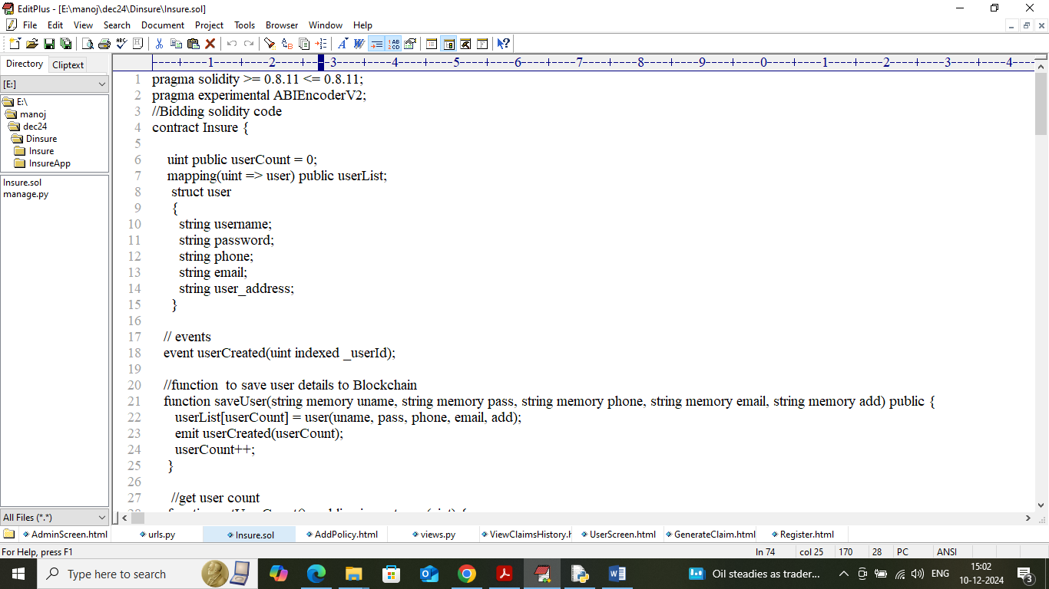

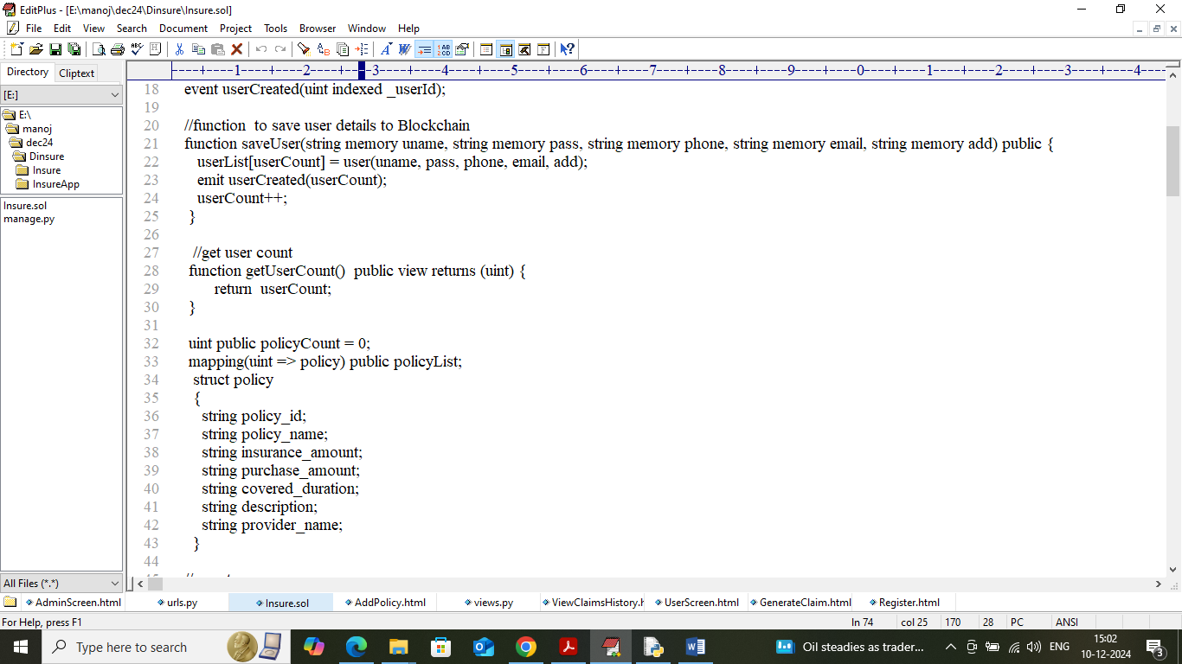

In above screen showing Smart Contract code which contains functions to manage user and insurance policy details. Now we need to deploy above contract in Blockchain Ethereum by following steps

1. First go inside ‘hello-eth/node-modules/bin’ folder and then look and double click on ‘runBlockchain.bat’ file to get below page
2. 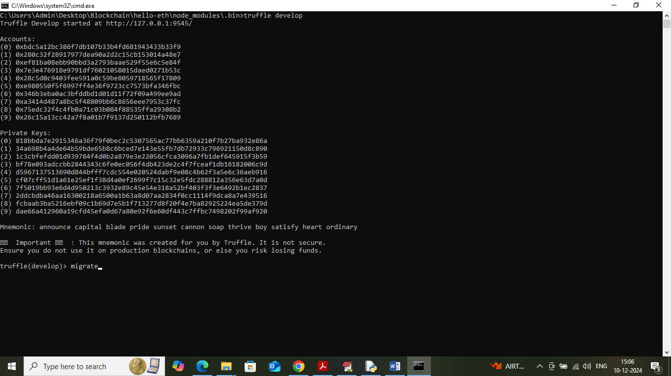
3. In above screen Blockchain Ethereum started with default keys and accounts and now type command as ‘migrate’ and then press enter key to deploy smart contract and get below page
4. 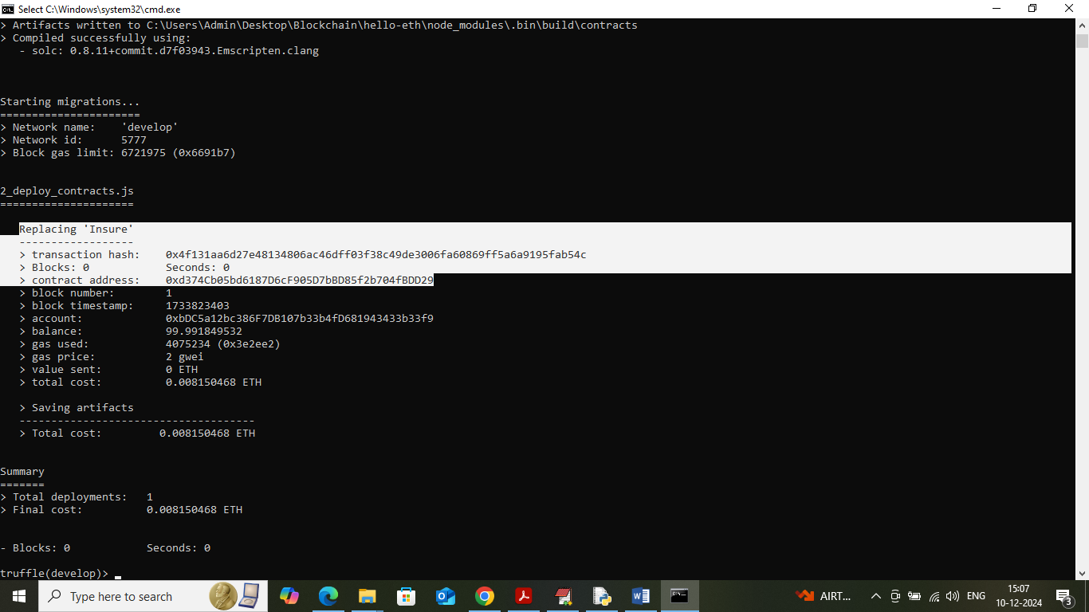
5. In above screen in white colour text can see ‘Insure’ contract deployed and got contract address also and this address need to specify in python code to call contract to save and get data. In below screen showing python code calling above contract using address
6. 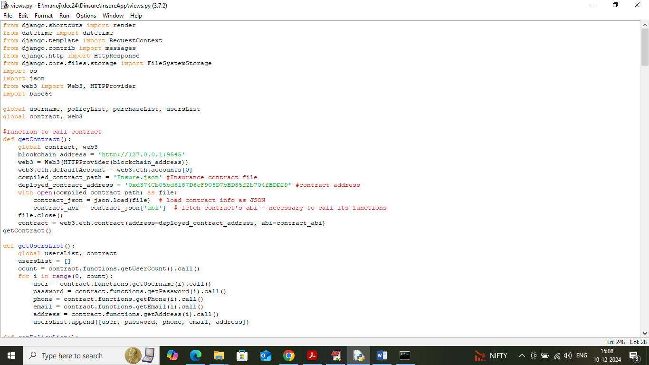
7. In above screen read red colour comments to know about contract calling using python and in above screens we have shown how to deploy contract and start Ethereum server and in above screen Blockchain server is running and let it run till the execution of the code.

To implement this project we have designed following modules

1. Admin: admin can login to system using username and password as ‘admin and admin’. After login admin can add ‘New insurance Policies’ and can view list of purchaser and can view list of claim request and then can approve or reject claims and can view each user wise claim history
2. User Sign up: user can sign up with the application
3. User Login: user can login to system
4. View Policies: can view list of available policies and can make purchase off desired policies
5. Claim Request: can generate request for claim
6. Claim Status: can view status of generated claim

Now double click on ‘runServer.bat’ file to start python web server and get below page

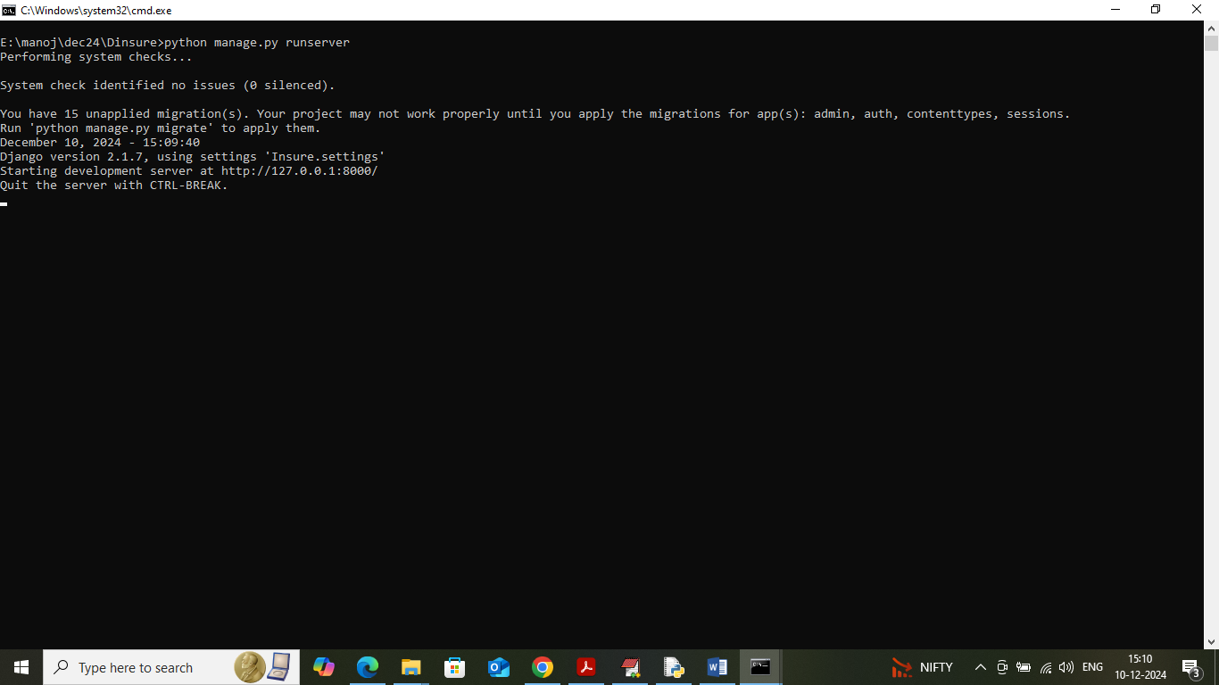

In above screen python server started and now open browser and enter URL as <http://127.0.0.1:8000/index.html> and then press enter key to get below page

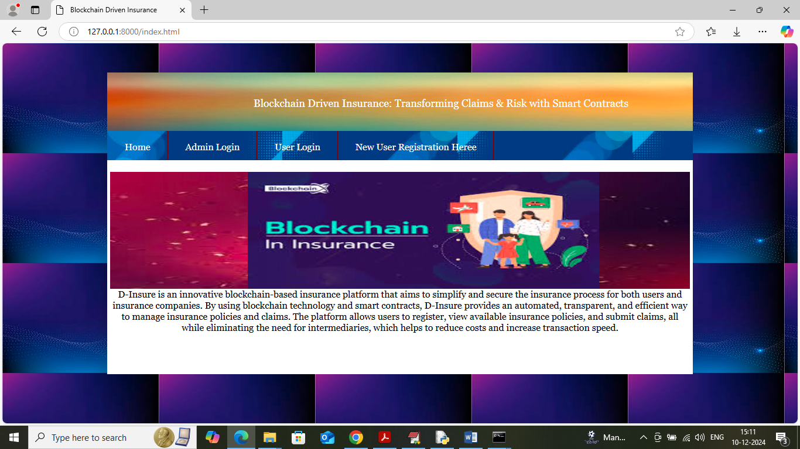

In above screen click on ‘Admin Login’ link to get below page

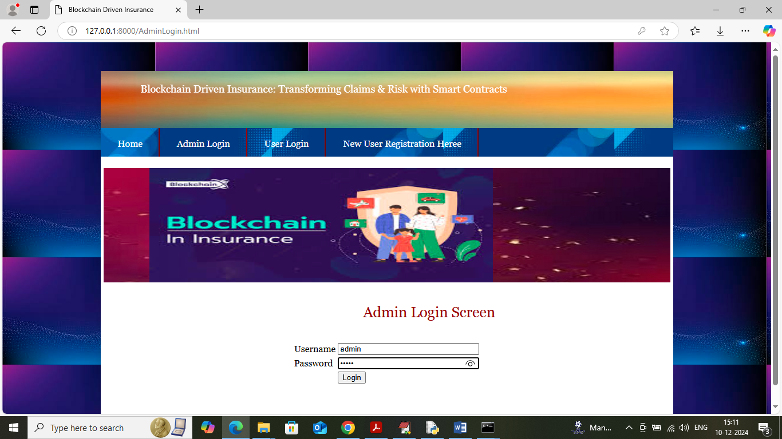

In above screen admin is login and after login will get below page

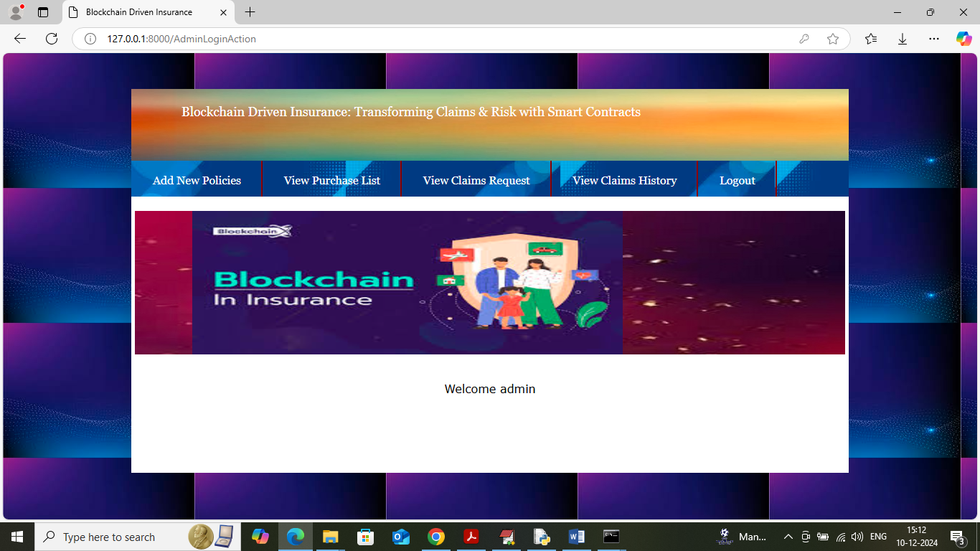

In above screen admin can click on ‘Add New Policies’ link to get below page

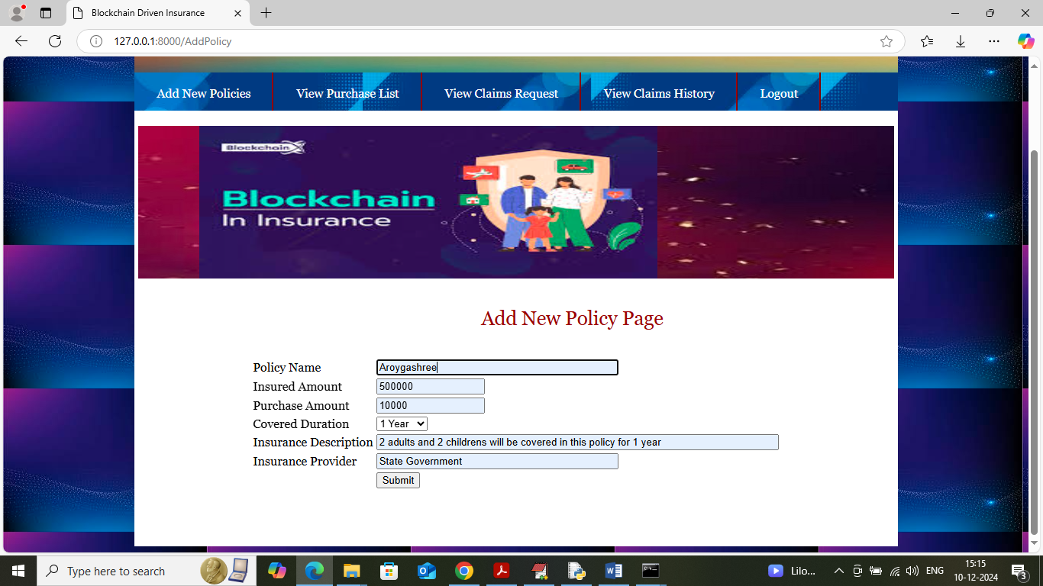

In above screen admin is adding policy details and then click on ‘Submit’ button to add policy details to Blockchain and get below page

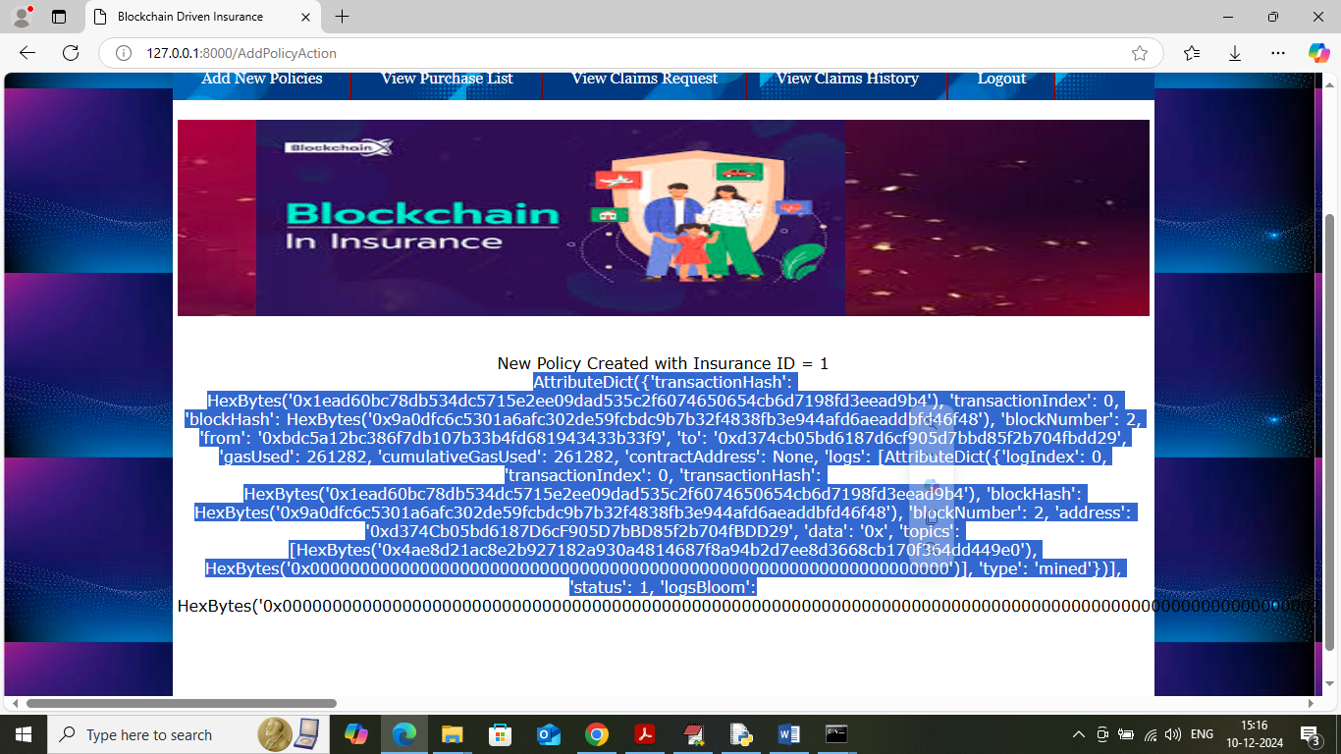

In above screen insurance policy created with ID 1 and then I am displaying all log details obtained from Blockchain after storage. This log I am displaying for your understanding purpose and this log contains details like Block No, Transaction No, transaction hash code and many other details. Now logout and login as user to purchase and generate claim

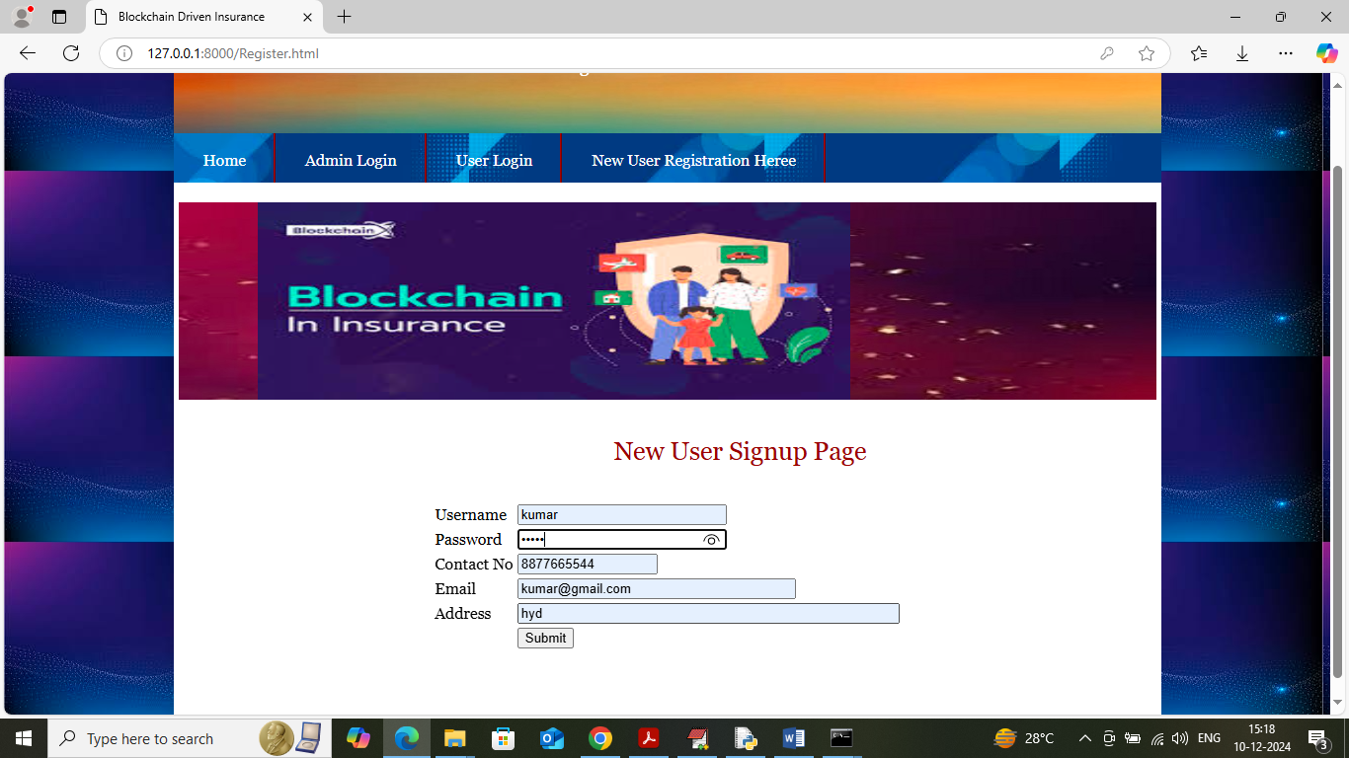

In above screen user first will get registered with the application and then press button to get below page

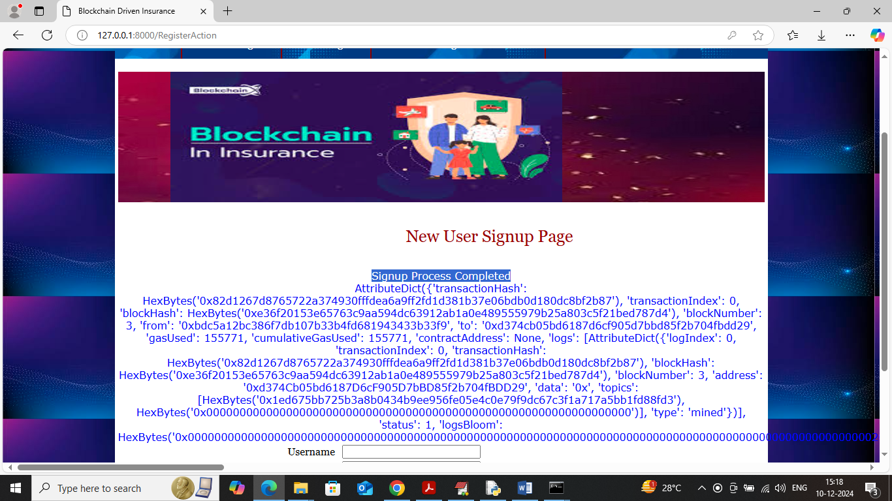

In above screen user sign up process completed and can see all Blockchain storage details log and now click on ‘User Login’ link to get below page

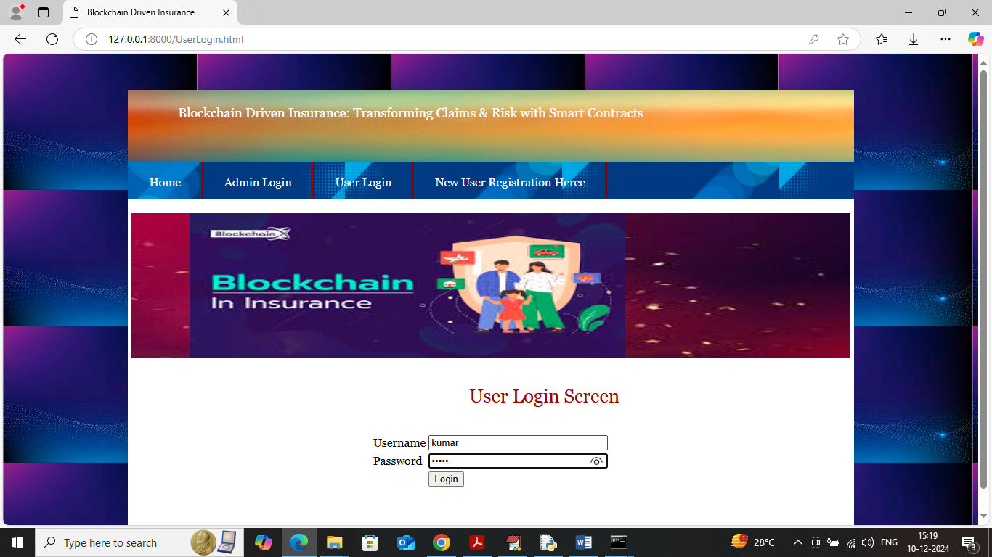

In above screen user is login and after login will get below page

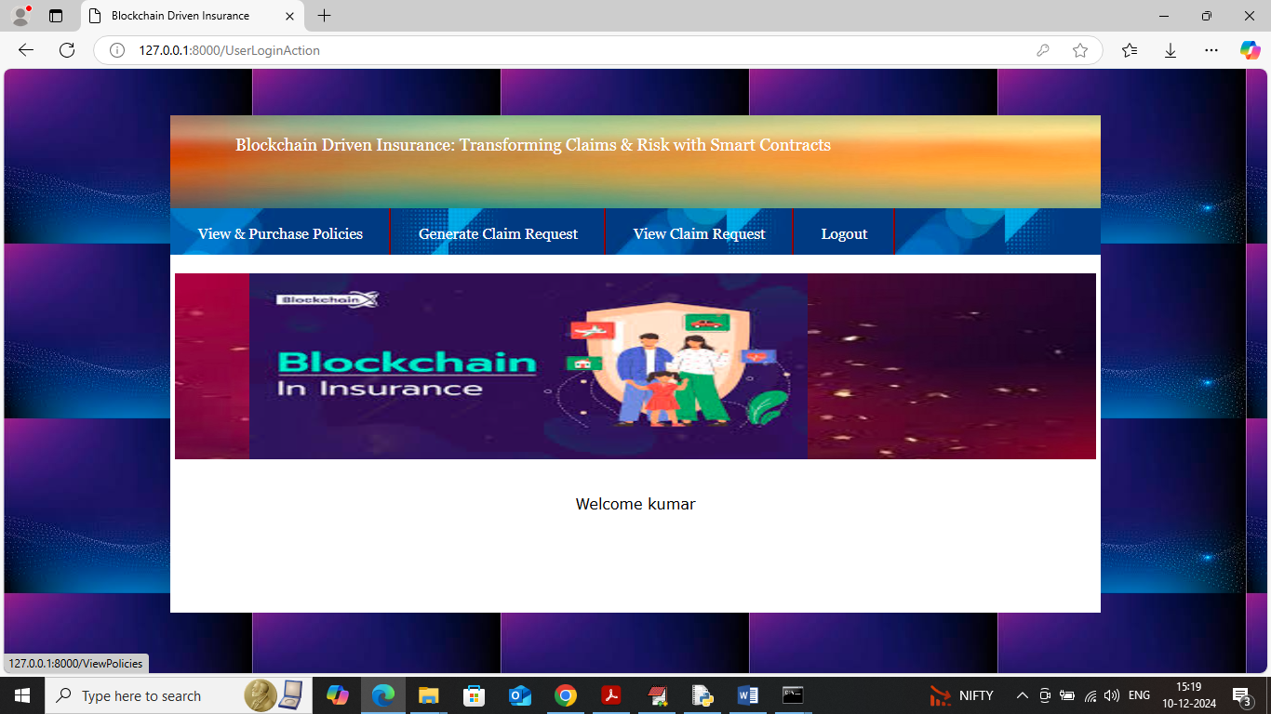

In above screen user can click on ‘View & Purchase Policies’ link to get below output

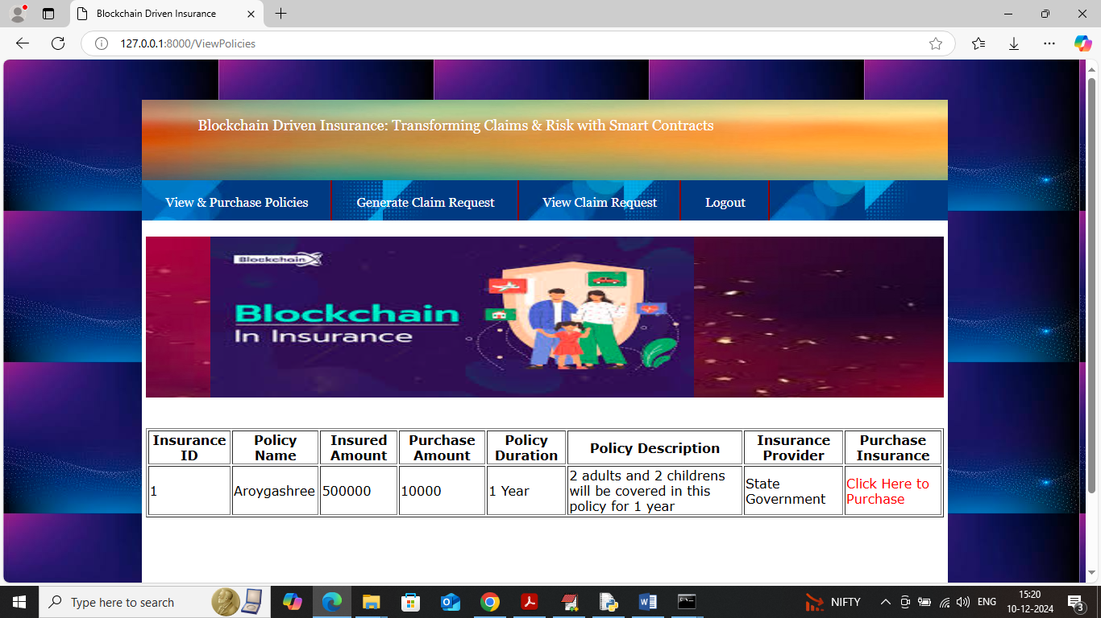

In above screen user can view list of available policies and can purchase desired policy by clicking on red colour link and then will get below output

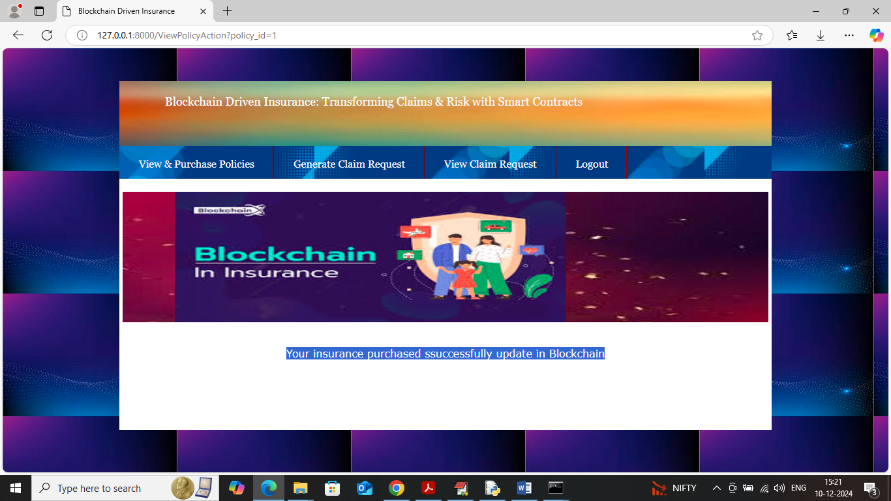

In above screen user purchase policy successfully updated in Blockchain and now click on ‘Generate Claim Request’ link to get below page

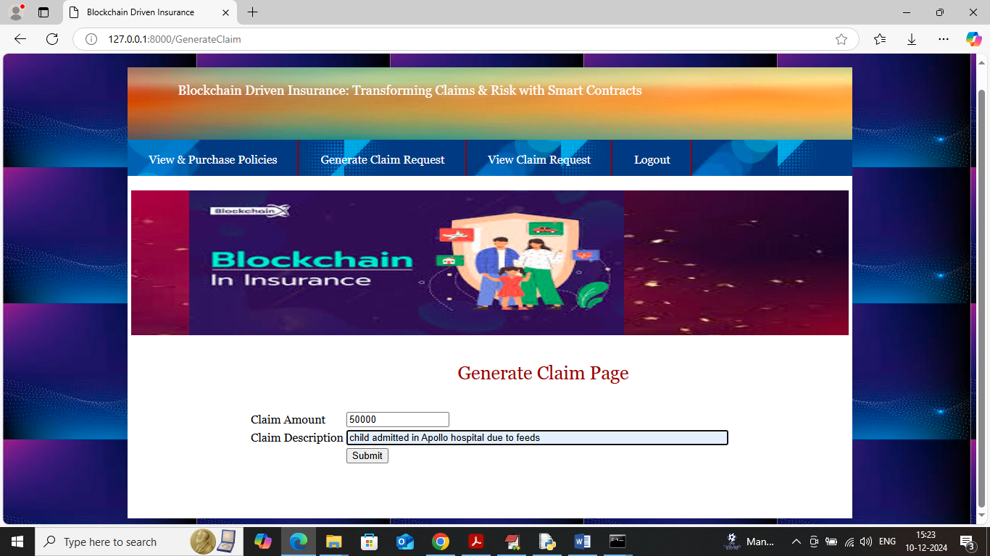

In above screen user is submitting claim to provider by entering some description and then press button to get below page

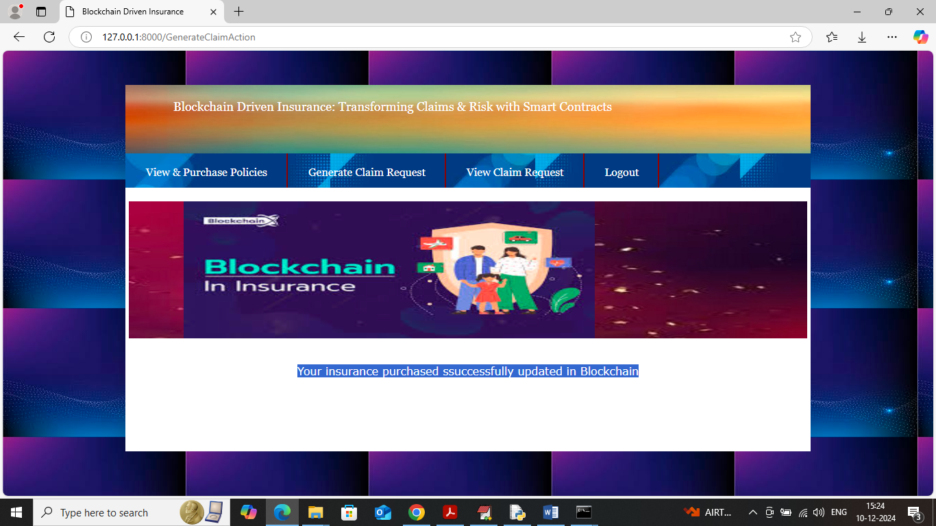

In above screen user claim successfully updated to Blockchain and now click on ‘View Claim Request’ link to get below page

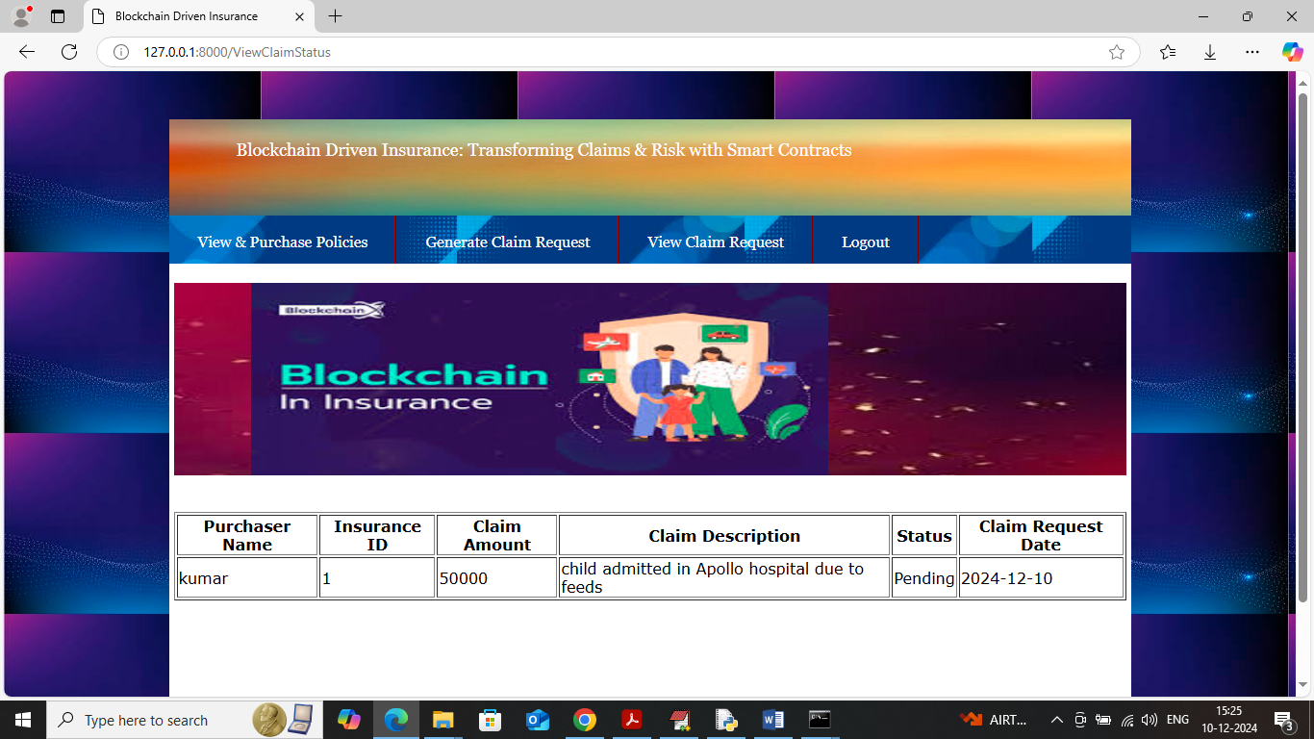

In above screen user can view his claim status is in pending state and now login as admin to approved or reject claim.

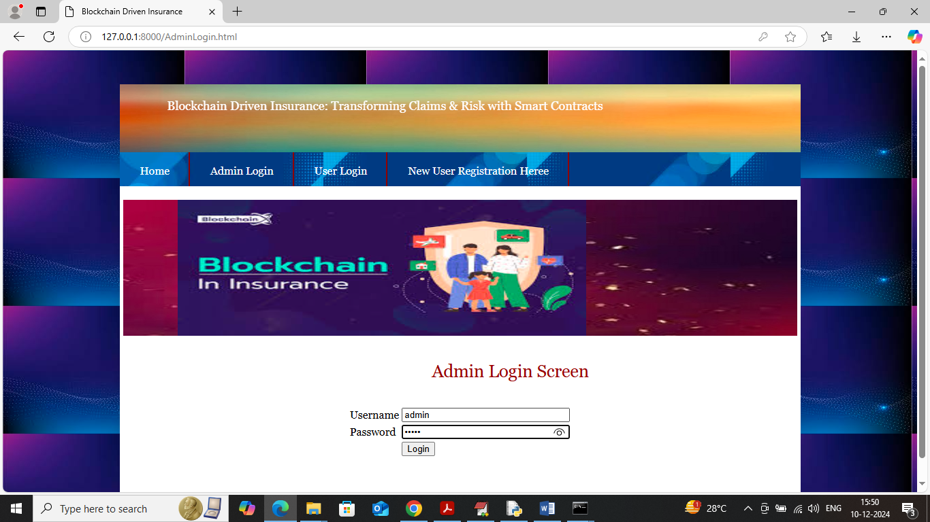

In above screen admin is login and after login will get below page

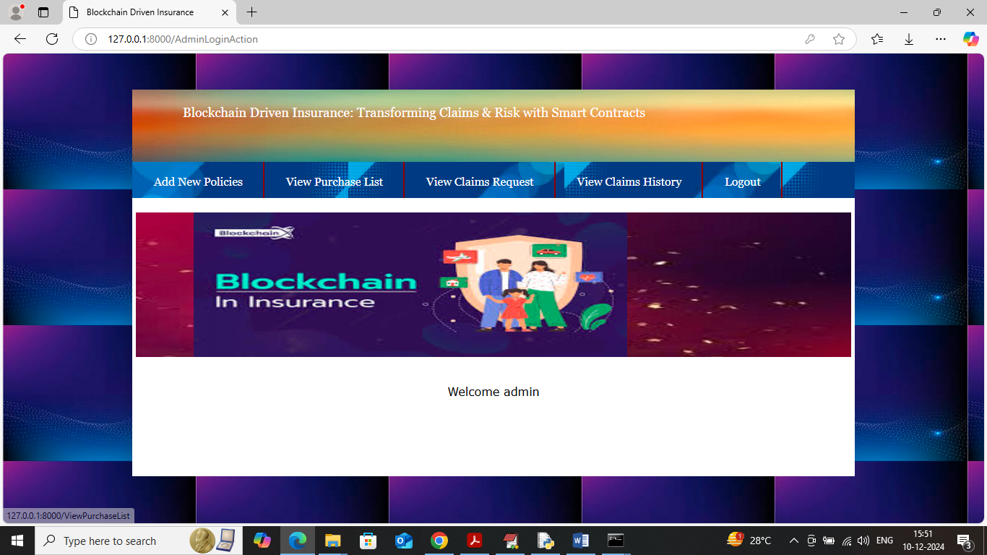

In above screen admin can click on ‘View Purchase List’ link to get list of users who purchase policies

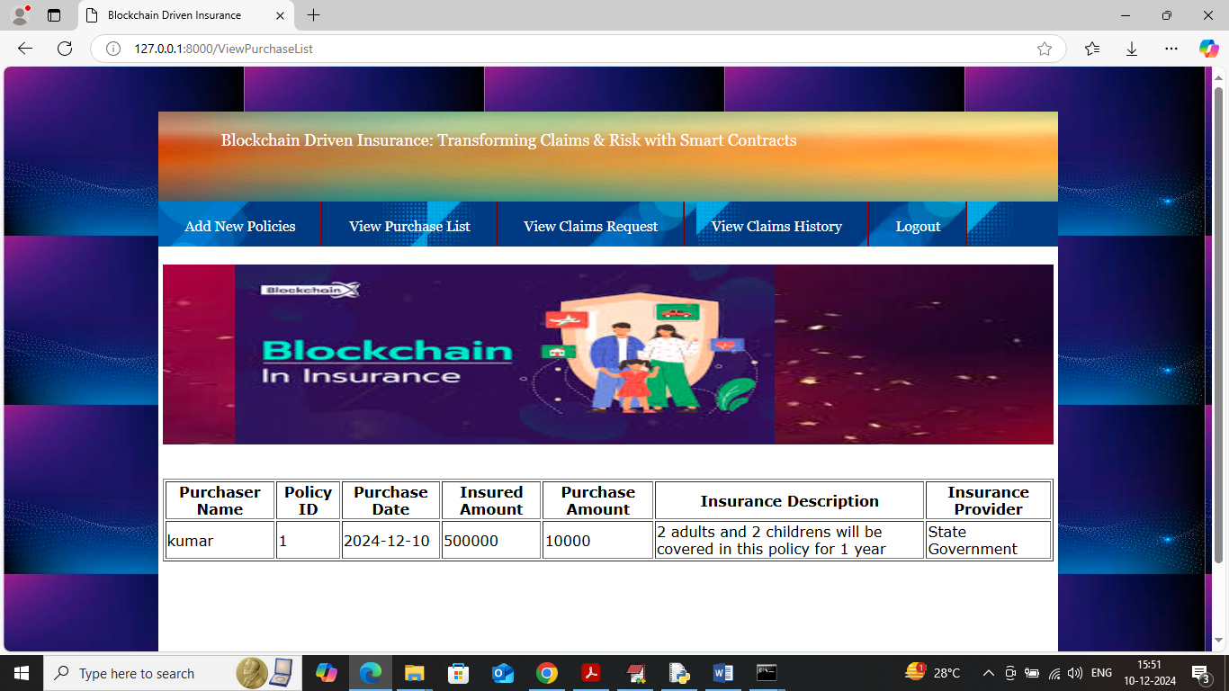

In above screen admin can view which user purchase which insurance ID and can click on ‘View Claims Request’ link to view list of claims submitted by users

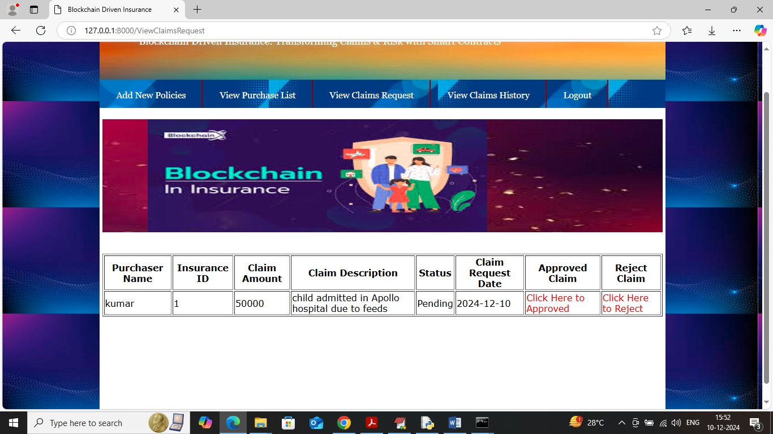

In above screen admin can view list of claim request and can click on red line ‘approved or reject’ to approve or reject and get below page

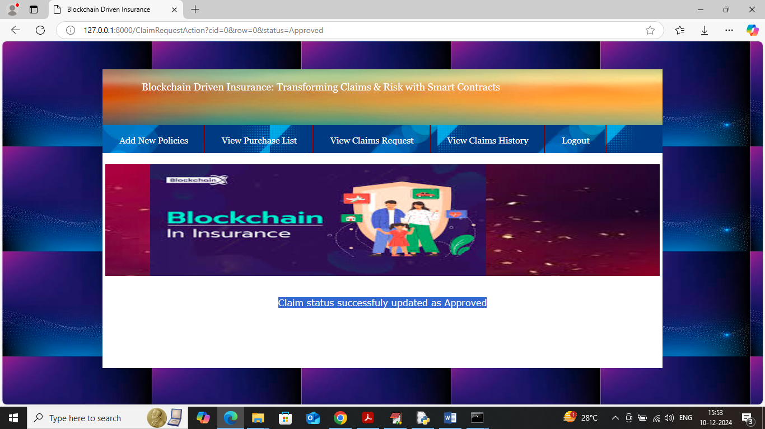

In above screen admin can view claim request is successfully updated and now click on ‘View Claim History’ to view list of claim history submitted by each user

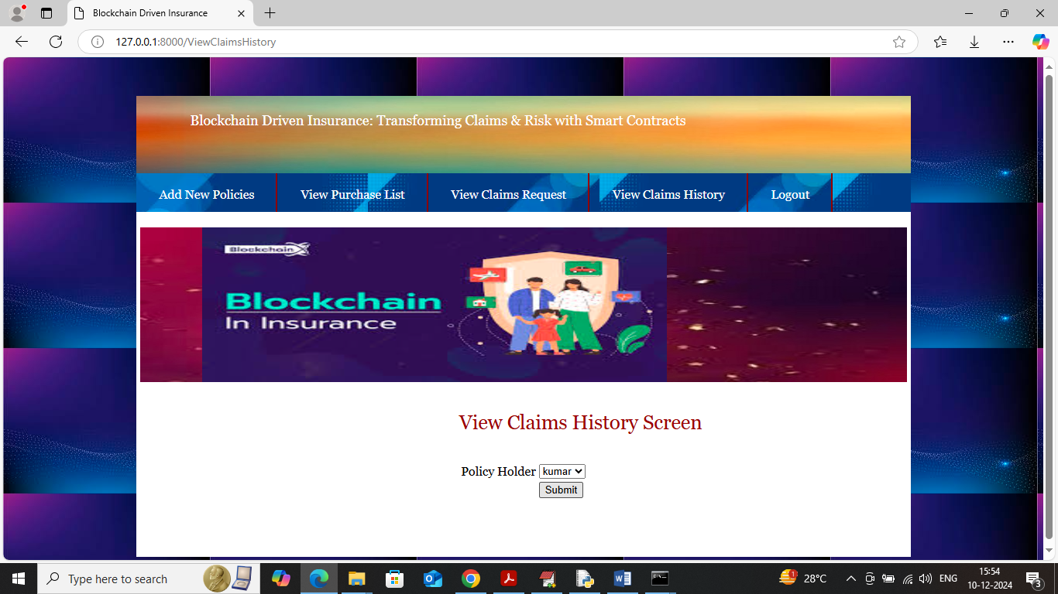

In above screen admin can select desired username and then click on button to get below page

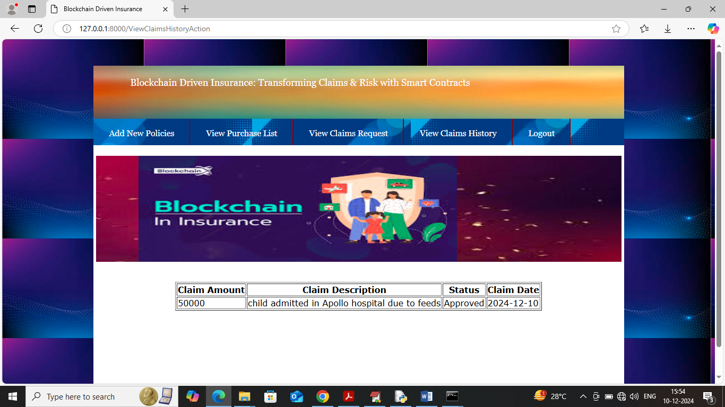

In above screen admin can view history of claims request and with approved or reject status.

Similarly by following above screens admin can add policies and approve and user can purchase and submit claim request.